**NP 369 CCNA Notes**

Subnet

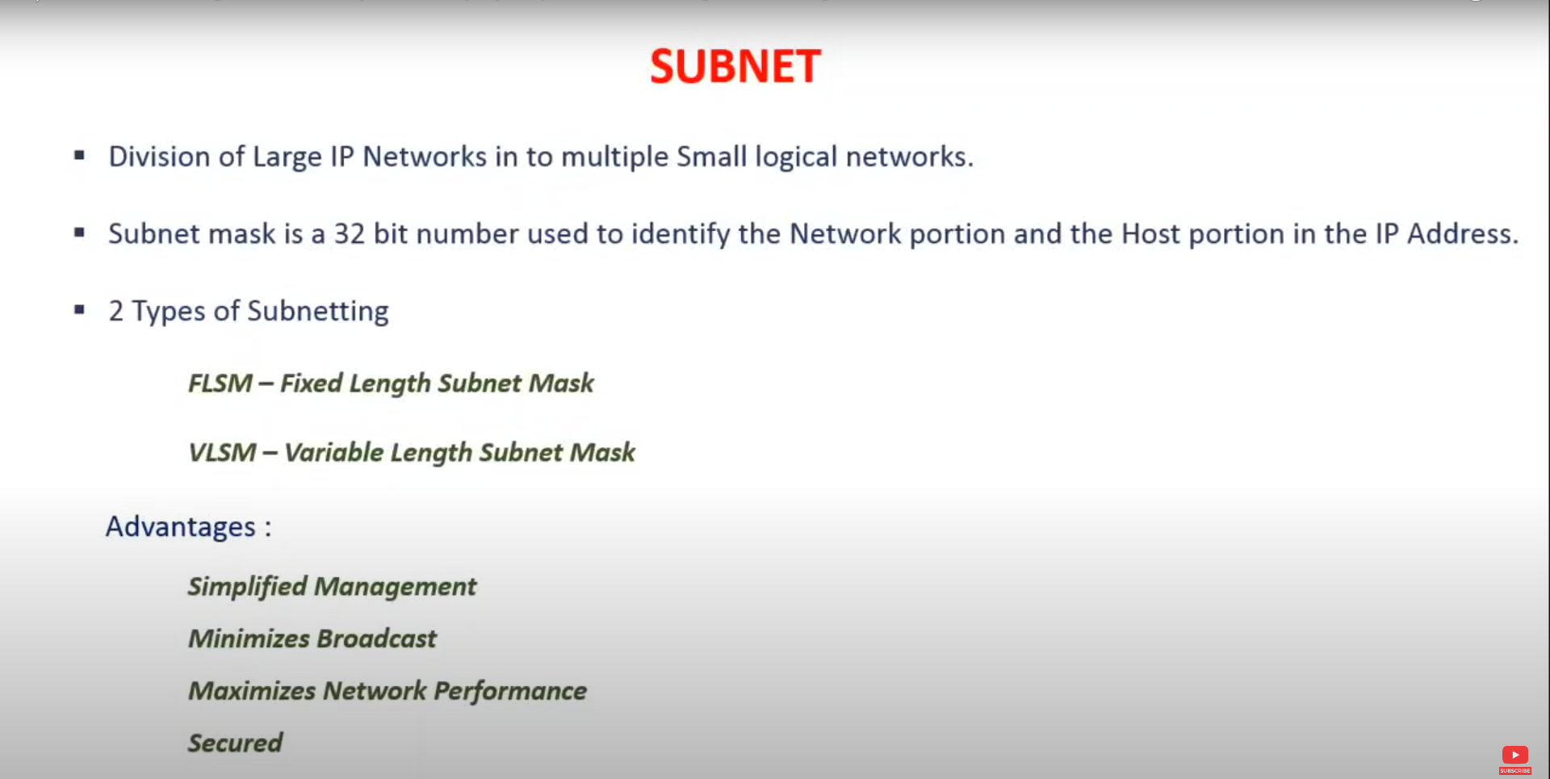

Fixed-Length Subnet Mask - FLSM

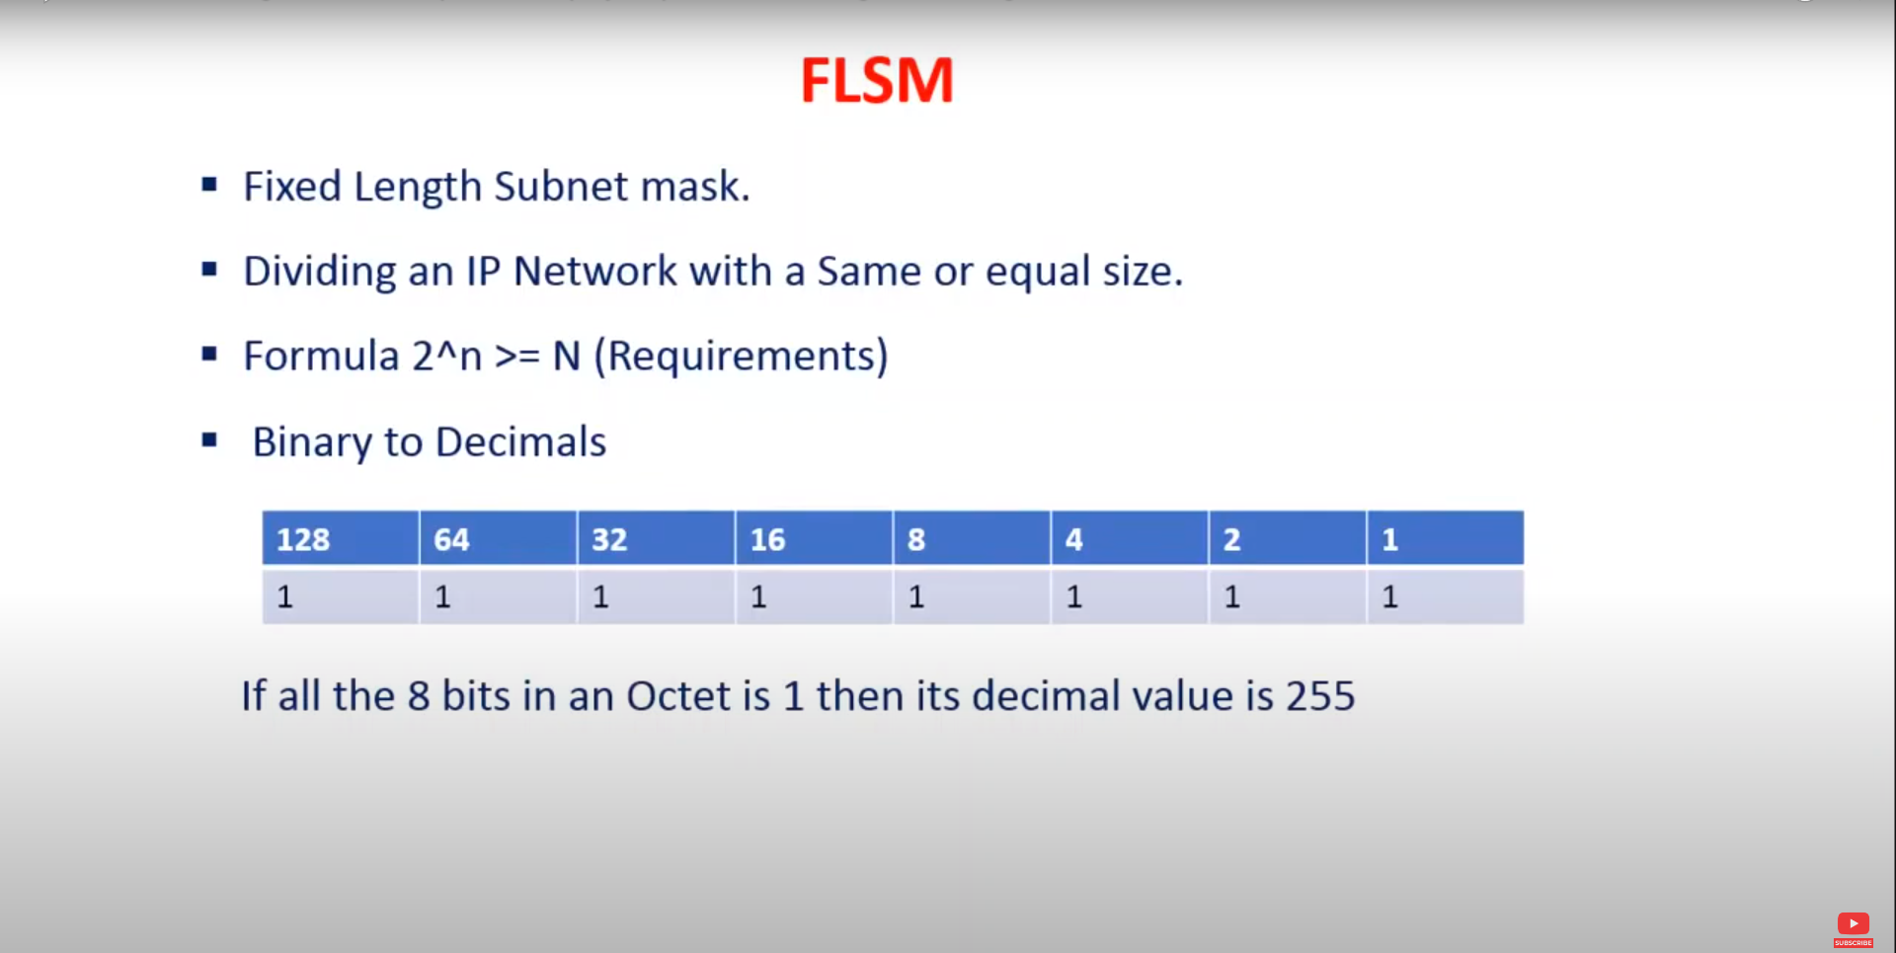

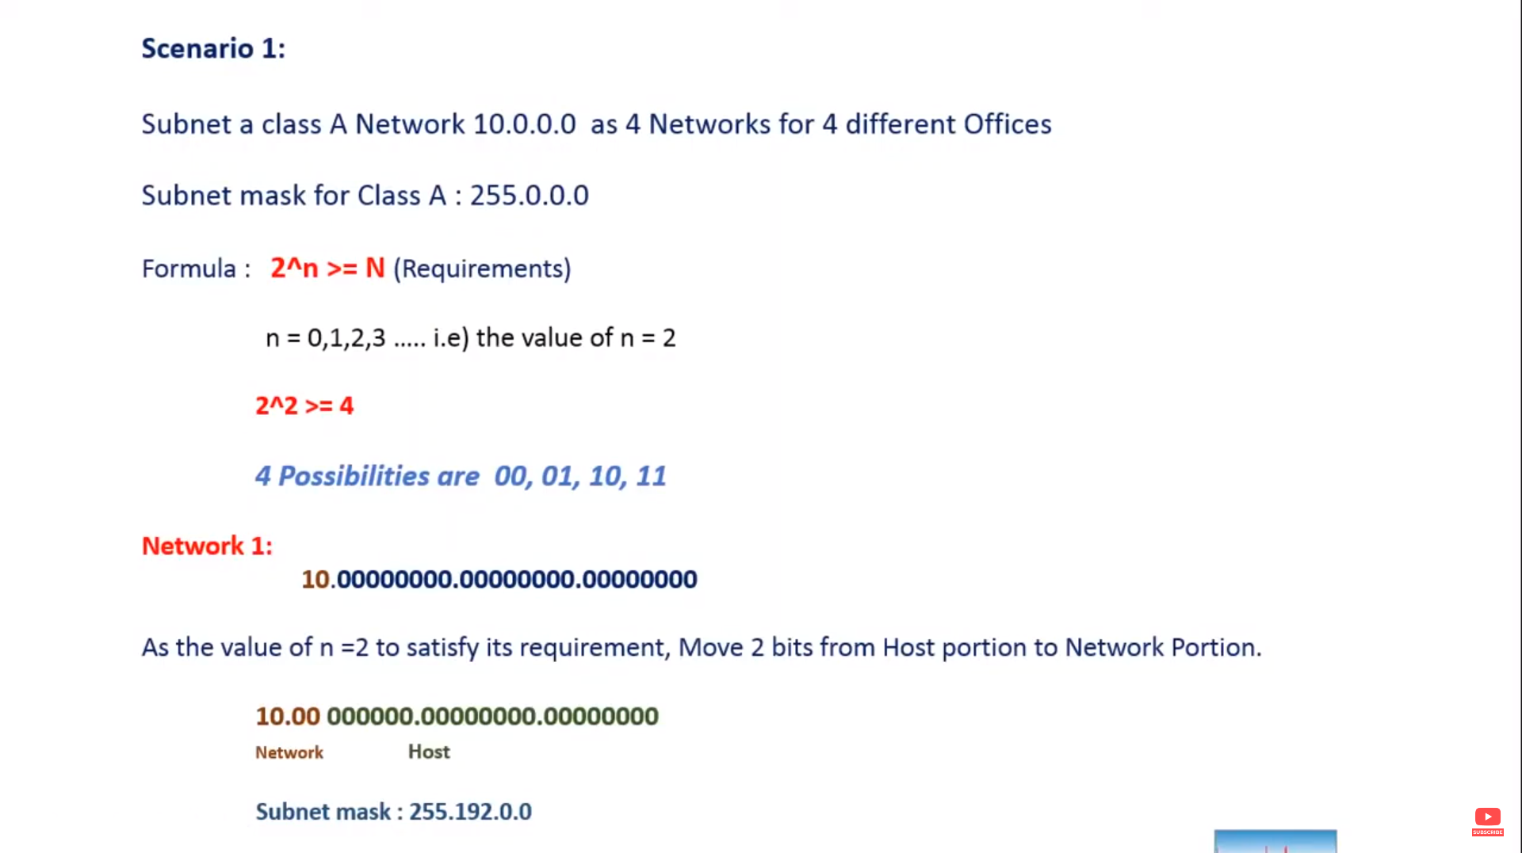

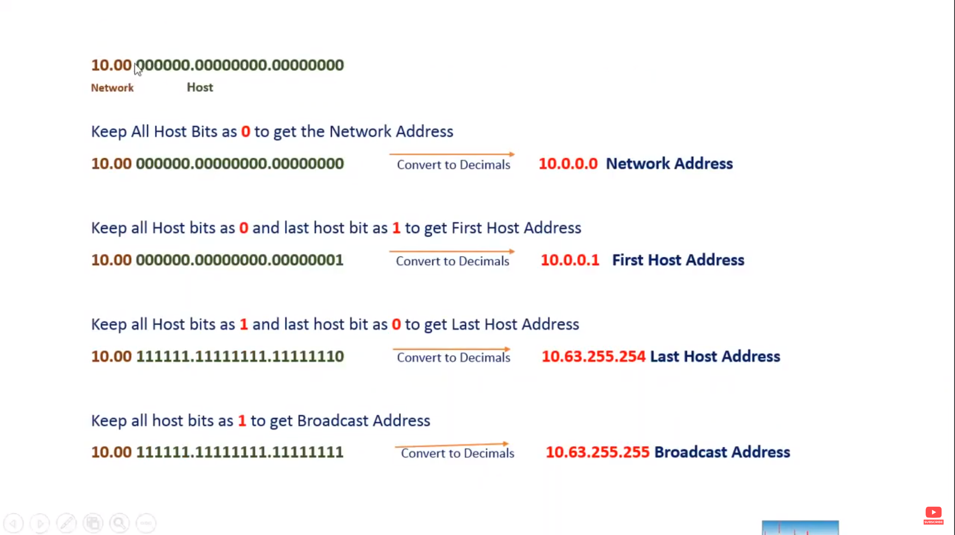

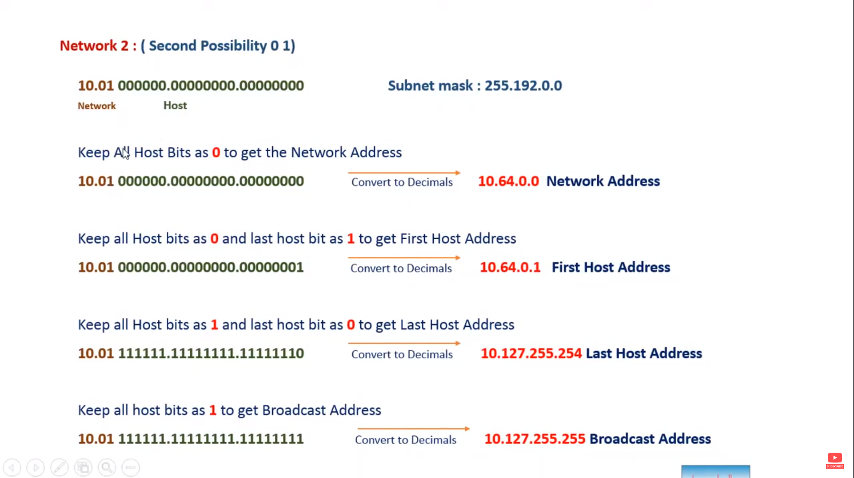

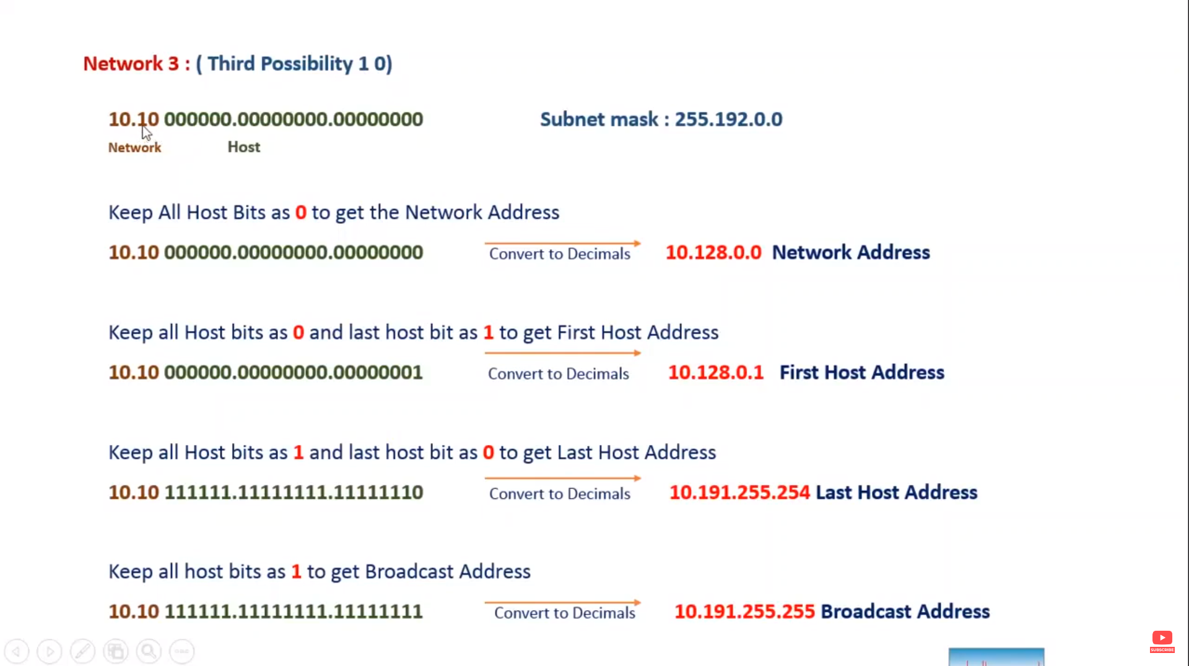

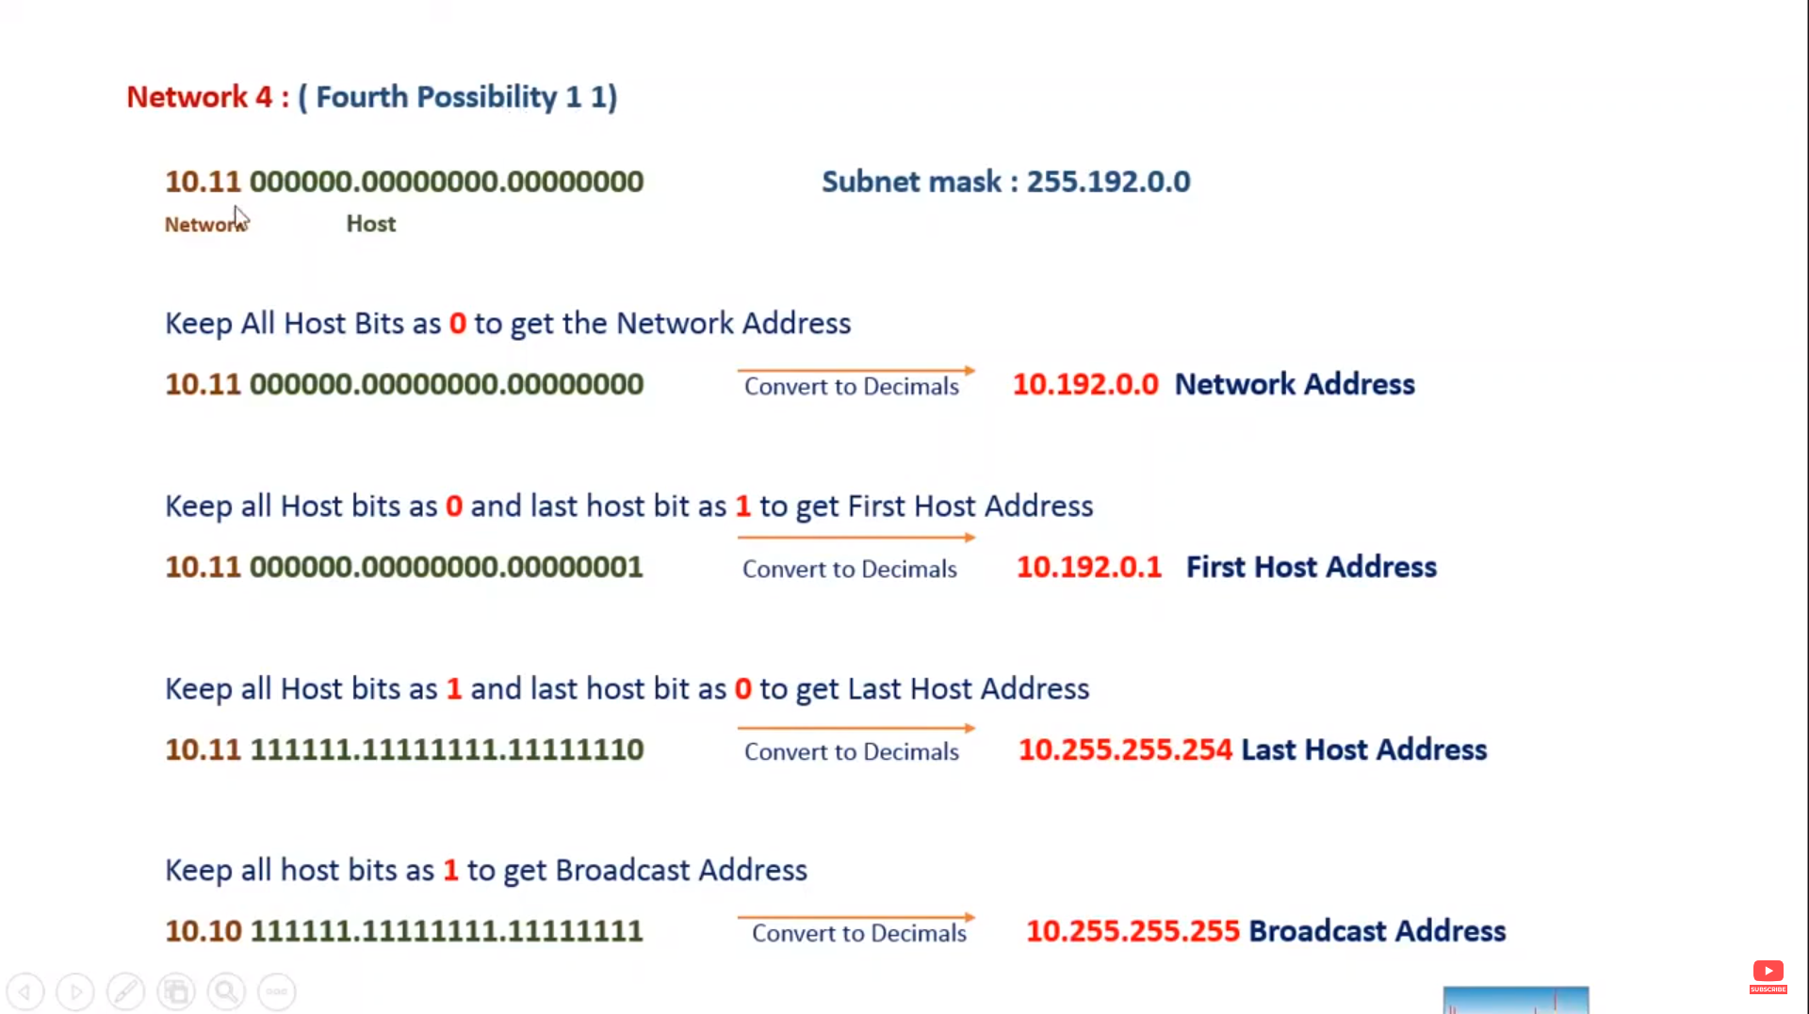

Local Area Network – LAN

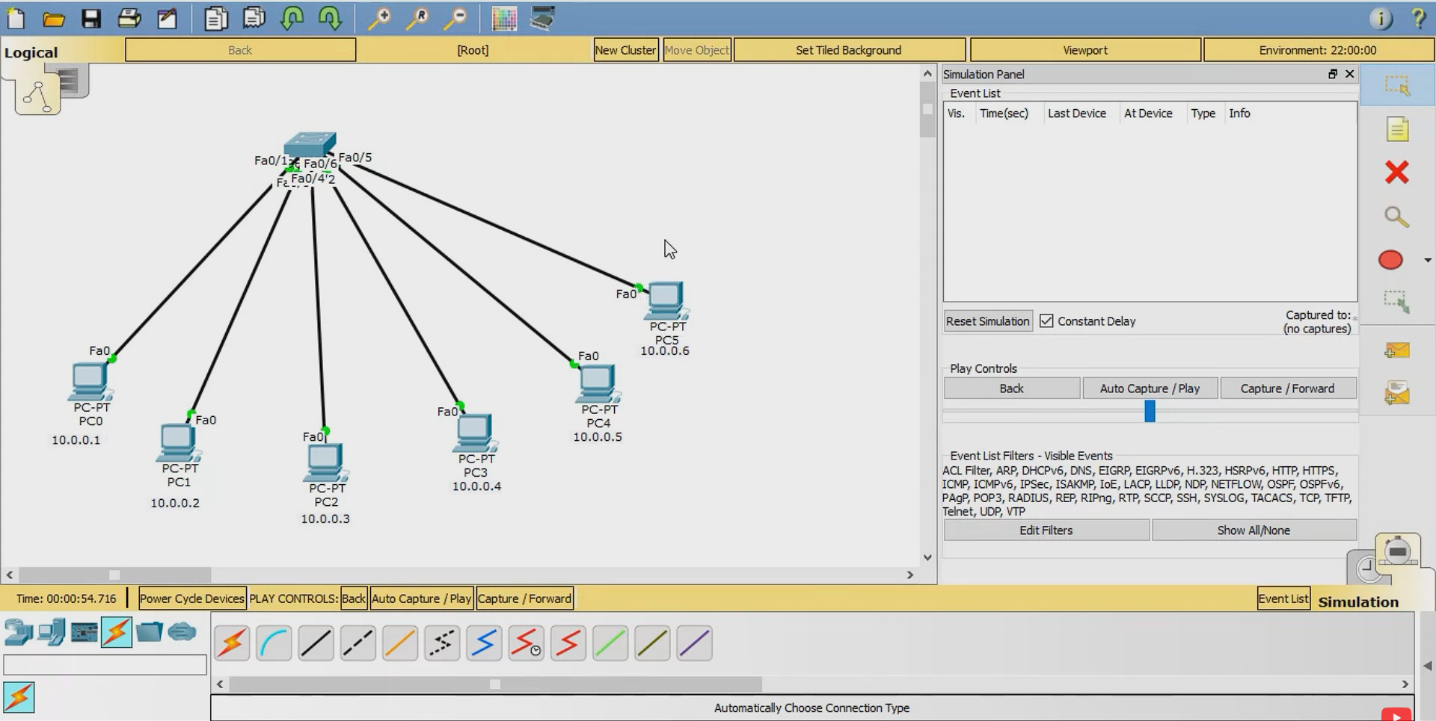

Virtual Local Area Network - VLAN

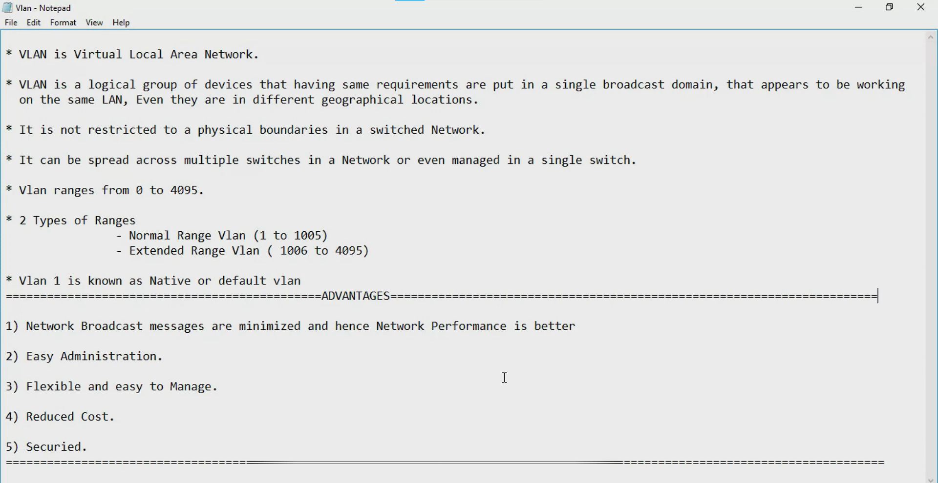

VLAN Access Port

It allows declared vlan in that port.

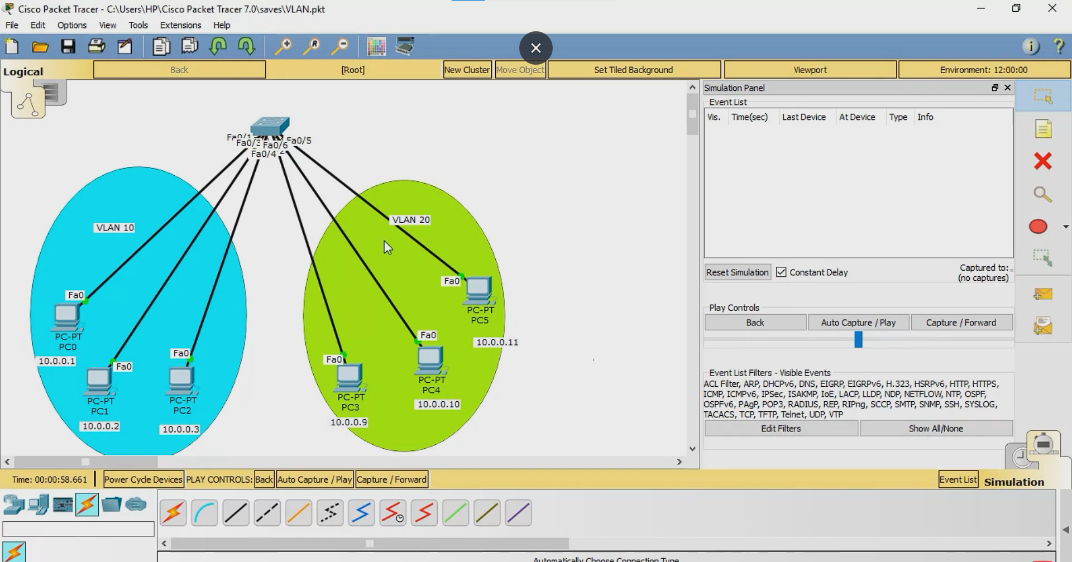

Commands for creating VLAN in switch

1. Show running-config = it show the current running configuration of the switch.
2. Config terminal = to create vlan first get into the configuration mode.
3. Vlan 10 = this vlan 10 is the id of that vlan network. Only numbers are using to create id and that numbers are between 0 to 4095 range only.
4. Name Research and Development = any name can assign and this name is optional.
5. Exit = this exit form the config-vlan mode.
6. Int range fastEthernet 0/1-2 = assigning the already created vlan 10 to interface or port in switch.
7. Switchport mode access = converting the ports to access port for assigning the vlan.
8. Switchport access vlan 10 = passing the vlan 10 id for that port. That means the port allows only vlan 10 network communicate within the vlan 10 network.
9. Exit = exeting for the vlan config mode.
10. Show vlan brief = it shows the vlan details.

Trunk Port

Trunk port allows multiple VLAN in a single port.

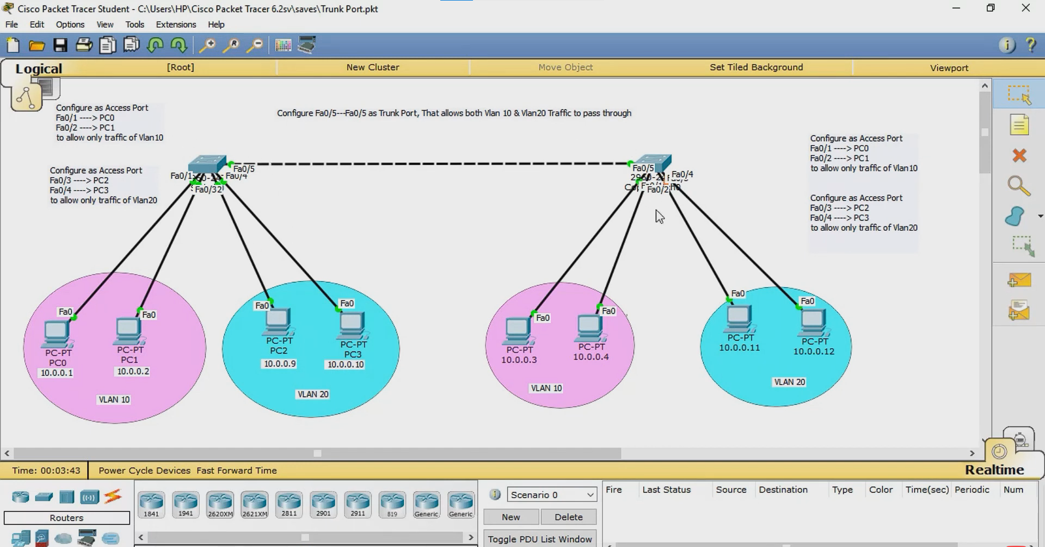

Command to configure Trunk port

1. Config terminal = first want to create vlan so get into the configuration mode.
2. Vlan 10 = this vlan 10 is the id of that vlan network. Only numbers are using to create id and that numbers are between 0 to 4095 range only.
3. Exit = this exit form the config-vlan mode.
4. Interface range fastEthernet 0/1-2 = assigning the already created vlan 10 to interface or port in switch.
5. Switchport mode access = converting the ports to access port for assigning the vlan.
6. Switchport access vlan 10 = passing the vlan 10 id for that port. That means the port allows only vlan 10 network communicate within the vlan 10 network.
7. Exit = exeting for the vlan config mode.